Nishay Madhani (00212195)

**Program Structures & Algorithms**

**Fall 2021**

**Assignment No. 2**

## 1. **Tasks Performed**

1. Implement the functions for *Timer.java*, run unit tests for *TimerTest* using modified values for the average running time.
2. Implement the InsertionSort algorithm in the *InsertionSort* class and use the *Helper* class.
3. Added a Unit test for insertion sort to *BenmarkTimerTest*
4. Added a main method to insertion sort to perform a doubling benchmark test.

## **2.Observation**

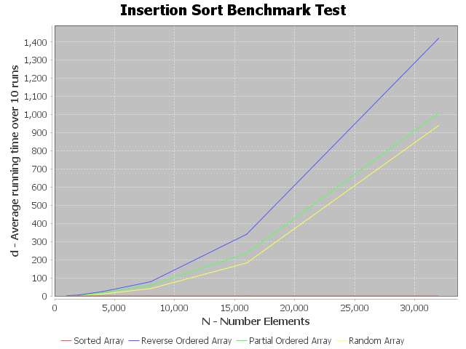

Based on the graph seen we can infer that for a random ordering where the expected running time of InsertionSort is O(N^2) is matching closely to the observed running time.

## 3. **Output**

Main Function in InsertionSort.java

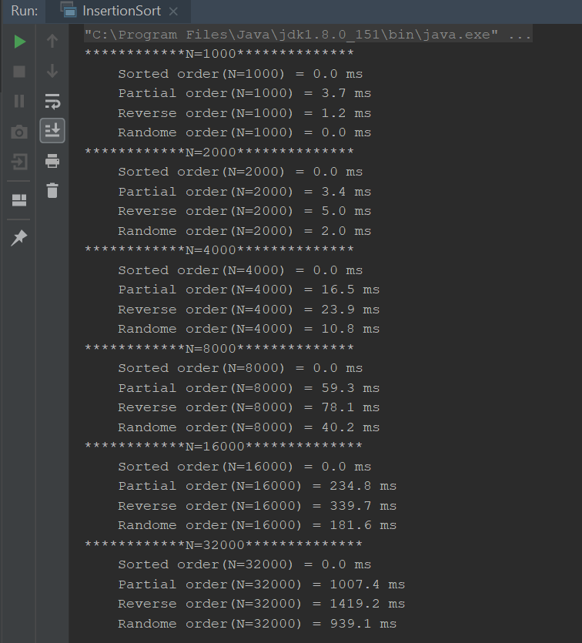

## 

## 4. **Unit Tests**

**TimerTest**

## 

Note: Delta values needed to be modified for the tests to work, this is due to differences in wait times depending on the thread pool configuration.(Only for TimerTest)

**InsertionSortTest**

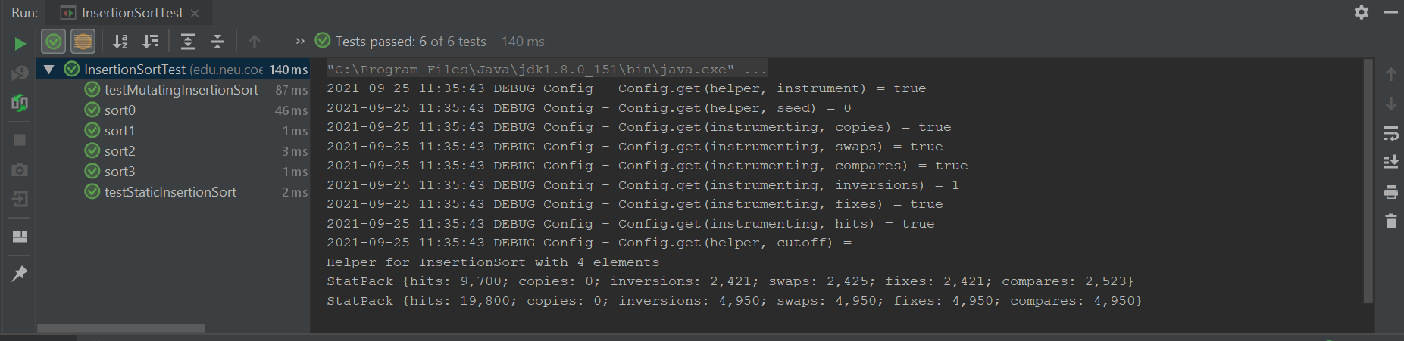

**BenchmarkTest**

